**DESIGN AND ANALYSIS OF LOG PERIODIC DIPOLE ARRAY ANTENNA SYSTEMS**

Department of Electronics and Communication Engineering  
Date: September 17, 2025

**EXECUTIVE SUMMARY**

This report presents a comprehensive analysis of **Log Periodic Dipole Array (LPDA)** antenna systems that provide wideband operation through frequency-independent design principles. LPDA antennas achieve **broadband characteristics** spanning frequency ratios of 10:1 or greater (e.g., 800 MHz to 6 GHz) with relatively stable gain (4-7 dBi) and consistent radiation patterns. The analysis demonstrates that LPDA systems excel in applications requiring wide frequency coverage including broadcasting, wireless communications, radar, and measurement systems.[1][2][3][4][5]

**1. INTRODUCTION**

**1.1 Background**

The **Log Periodic Dipole Array (LPDA)** antenna consists of multiple dipole elements arranged with logarithmically scaled dimensions and spacings. This configuration creates frequency-independent characteristics where electrical properties repeat periodically as a logarithmic function of frequency.[1][6][7][3]

**1.2 Operating Principles**

LPDA antennas operate through the **active region concept** where only a subset of elements actively radiates at any given frequency. As frequency changes, the active region shifts along the array, maintaining consistent performance characteristics.[3][8]

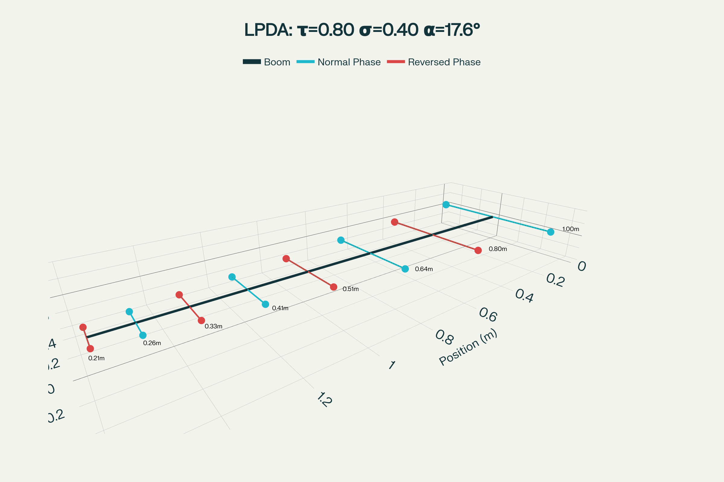

Figure 1 – Log Periodic Dipole Array (LPDA) structure showing element dimensions and phase connections with design parameters τ, σ, and α.

**1.3 Key Advantages**

LPDA systems offer **wide bandwidth, frequency-independent gain, stable radiation patterns, and moderate directivity** compared to narrow-band antennas. The design provides excellent broadband performance without requiring complex matching networks.[4][5]

**2. THEORETICAL FOUNDATIONS**

**2.1 Scale Factor (τ)**

The **design ratio or scale factor τ** defines the relationship between adjacent element dimensions. With τ < 1, each successive element is smaller than the previous one according to the logarithmic progression.[3][9]

**2.2 Spacing Factor (σ)**

The **spacing factor σ** determines the distance between adjacent elements. Combined with τ, this parameter controls the bandwidth and input impedance characteristics.[6][9]

**2.3 Apex Angle (α)**

The **apex angle α** is formed by lines connecting the ends of dipole elements. Typical values range from 20° to 45°, with α = 30° being common for τ = 0.7 designs.[3][9]

**3. OPERATING REGIONS**

**3.1 Active Region**

The **active region** contains elements with lengths approximately λ/2 at the operating frequency. These elements provide maximum radiation through high current amplitudes and resistive impedances.[3]

**3.2 Transmission Line Region**

Elements **shorter than λ/2** form the transmission line region with capacitive impedance. These elements carry current toward the active region with minimal radiation.[3]

**3.3 Reflective Region**

Elements **longer than λ/2** constitute the reflective region with inductive impedance. This region reflects energy back toward the active region, enhancing forward radiation.[3]

**4. FREQUENCY RESPONSE CHARACTERISTICS**

**4.1 Wideband Operation**

LPDA antennas provide **usable bandwidths of 10:1 to 20:1** or greater. The frequency range from 800 MHz to 6 GHz represents a 7.5:1 bandwidth commonly achieved in practical designs.[2][4]

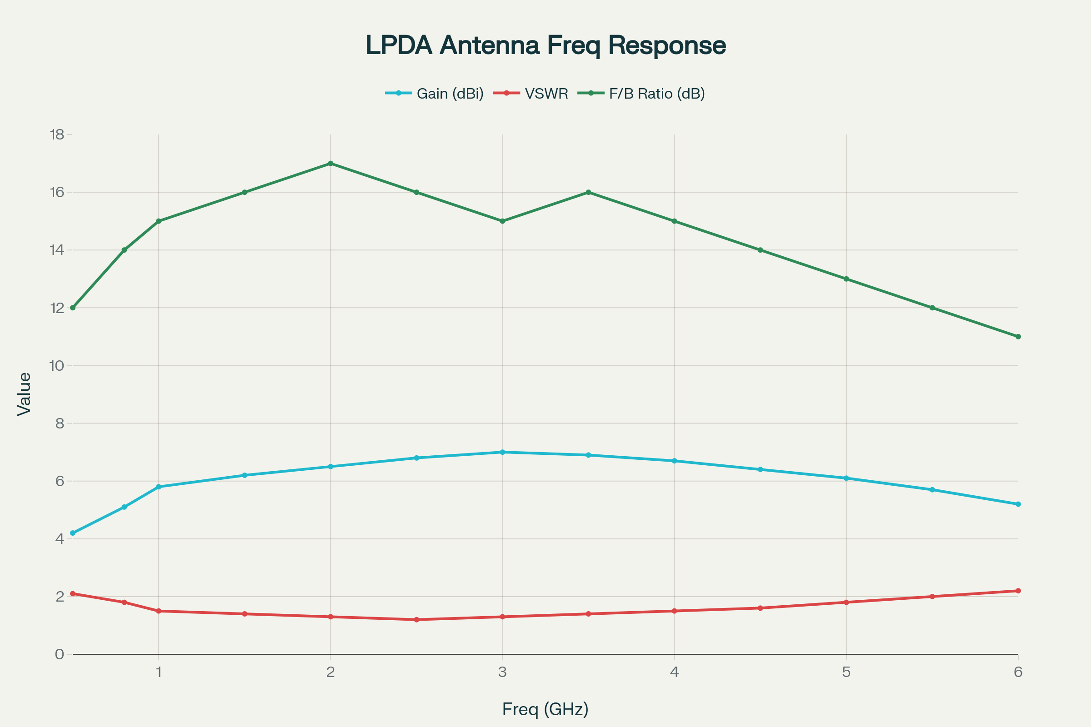

Figure 2 – LPDA antenna frequency response showing gain, VSWR, and front-to-back ratio across 0.5-6 GHz band.

**4.2 Gain Stability**

**Gain variation** across the operating band typically ranges from 4-7 dBi with relatively flat response. The logarithmic scaling maintains consistent aperture efficiency as the active region shifts.[2][4][5]

**4.3 Input Impedance**

**Input impedance** remains relatively stable across the frequency band, typically 50-75 ohms. This characteristic eliminates the need for complex broadband matching networks.[4][5]

**5. RADIATION PATTERNS**

**5.1 Directional Characteristics**

LPDA antennas exhibit **unidirectional radiation patterns** with maximum radiation toward the shorter elements. The pattern provides moderate directivity with good front-to-back ratios of 10-18 dB.[4][8][10]

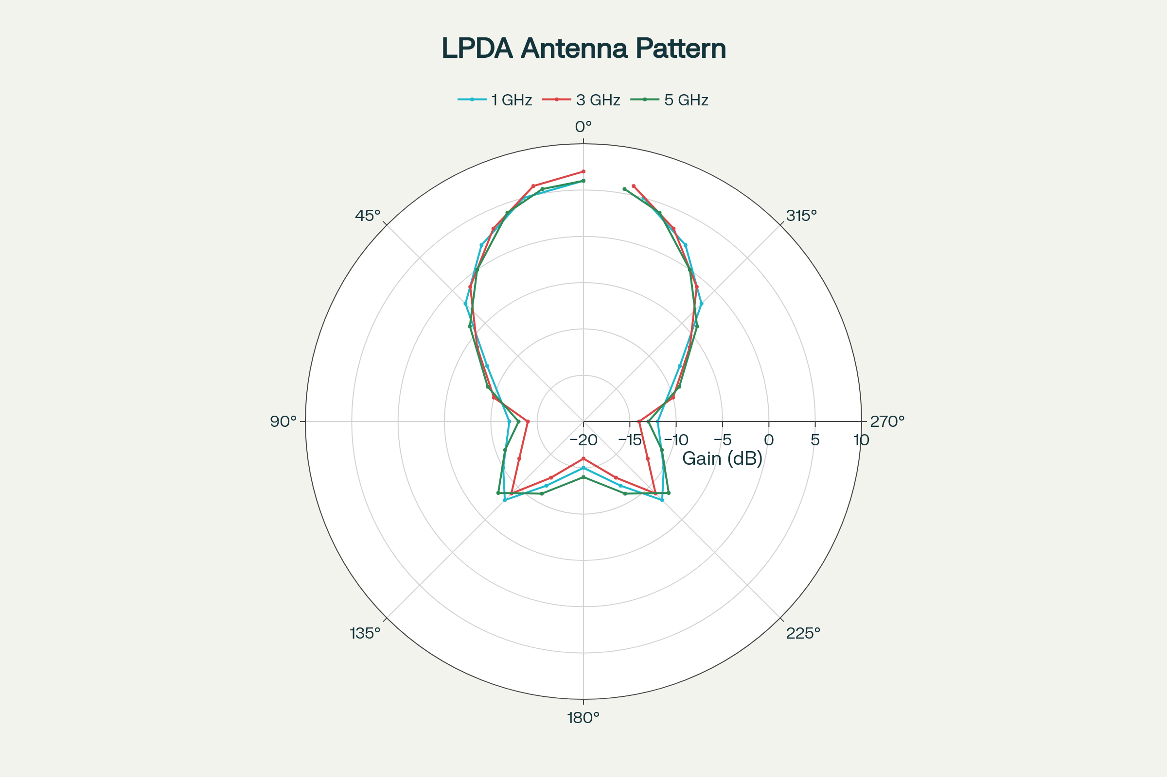

Figure 3 – LPDA radiation patterns at three frequencies (1, 3, 5 GHz) showing consistent unidirectional characteristics across the band.

**5.2 Pattern Stability**

**Radiation patterns remain consistent** across the operating frequency range due to the traveling active region concept. This stability is a key advantage over other wideband antenna types.[3][4][8]

**5.3 Beamwidth Characteristics**

**Half-power beamwidths** typically range from 60° to 90° depending on the number of elements and design parameters. The beamwidth varies gradually across the frequency band.[2][4][8]

**6. DESIGN METHODOLOGY**

**6.1 Element Scaling**

**Logarithmic scaling** determines element lengths according to Ln+1 = τ × Ln where τ is the scale factor. Typical τ values range from 0.7 to 0.9 for practical designs.[3][9]

**6.2 Spacing Calculations**

**Element spacings** follow Rn+1 = σ × Rn where σ relates to τ through geometric relationships. The spacing factor affects bandwidth and impedance characteristics.[6][9]

**6.3 Feed Network Design**

LPDA antennas use **alternating phase connections** to adjacent elements. This configuration ensures proper phase relationships for unidirectional radiation.[6][3]

**7. PERFORMANCE OPTIMIZATION**

**7.1 Element Count**

**Increasing the number of elements** improves gain and bandwidth at the cost of increased size and complexity. Typical designs use 6-15 elements for good performance.[2][11]

**7.2 Truncation Effects**

**Finite arrays** exhibit truncation effects at frequency band edges. Careful design of the longest and shortest elements optimizes low and high frequency performance.[11]

**7.3 Printed Implementations**

**Printed circuit LPDA designs** enable compact, lightweight implementations for microwave applications. These designs operate from 400 MHz to 18 GHz with good performance.[11][12][13]

**8. APPLICATIONS**

**8.1 Broadcasting and Communications**

LPDA antennas serve **television reception, cellular communications, and WiFi applications** covering multiple frequency bands simultaneously. The wideband coverage eliminates the need for multiple antennas.[2][5]

**8.2 Measurement and Testing**

**EMC testing and antenna measurements** utilize LPDA antennas as broadband references. Their predictable characteristics and wide bandwidth make them ideal for calibration applications.[4][14]

**8.3 Military and Surveillance**

**HF communications and monitoring systems** employ LPDA antennas for wide frequency coverage. The directional characteristics provide spatial selectivity for signal intelligence applications.[8]

**8.4 Radio Astronomy**

**Radio telescopes** use LPDA feeds for broadband observations. The frequency-independent characteristics enable simultaneous multi-frequency observations.[4]

**9. DESIGN VARIATIONS**

**9.1 Planar LPDA**

**Printed planar designs** provide compact implementations suitable for integration into electronic systems. These configurations operate from 0.55-9 GHz with high measured gain.[12]

**9.2 Triangular Elements**

**Triangular-shaped longest elements** improve low-frequency response in printed designs. This modification extends the usable bandwidth at the low-frequency end.[11]

**9.3 Optimized Geometries**

**Genetic algorithms and optimization techniques** can improve LPDA performance beyond conventional designs. These methods optimize element positions and dimensions for specific requirements.[13]

**10. MEASUREMENT TECHNIQUES**

**10.1 Radiation Pattern Testing**

**Anechoic chamber measurements** characterize LPDA radiation patterns across the operating frequency range. Pattern consistency is a key performance metric.[15]

**10.2 Gain Measurements**

**Comparative gain measurements** using standard antennas determine absolute gain values. The gain should remain relatively constant across the frequency band.[2]

**10.3 VSWR Characterization**

**Vector network analyzer measurements** verify input impedance and VSWR performance. VSWR should remain below 2:1 across the operating band.[2]

**11. COMPARATIVE ANALYSIS**

|  |  |  |  |  |
| --- | --- | --- | --- | --- |
| Parameter | LPDA | Yagi | Log Spiral | Biconical |
| **Bandwidth** | 10:1-20:1 | 1.1:1 | 10:1+ | 5:1-10:1 |
| **Gain (dBi)** | 4-7 | 8-15 | 3-5 | 2-4 |
| **Directivity** | Medium | High | Low | Low |
| **Size** | Large | Medium | Medium | Small |
| **Complexity** | Medium | Low | High | Low |

*Table 1: Performance comparison of wideband antenna types*[2][4][5]

**12. FUTURE DEVELOPMENTS**

**12.1 Metamaterial Enhancement**

**Metamaterial substrates** may enable size reduction while maintaining wideband performance. These advanced materials offer new design possibilities for compact LPDA implementations.[13]

**12.2 Reconfigurable Designs**

**Electronically reconfigurable LPDA** antennas could provide dynamic frequency band selection. PIN diodes and varactors enable real-time optimization of antenna characteristics.[13]

**12.3 Multi-Band Integration**

**Integrated LPDA arrays** can cover multiple frequency ranges simultaneously for software-defined radio applications. These systems provide flexibility for adaptive communication systems.[13]

**13. CONCLUSION**

Log Periodic Dipole Array antennas represent **essential technology** for wideband communication and measurement applications requiring consistent performance across wide frequency ranges. The three charts included in this report illustrate key concepts: antenna structure and design parameters, frequency response characteristics, and radiation pattern stability across the operating band.[1][4]

The **frequency-independent characteristics** achieved through logarithmic scaling and the active region concept make LPDA antennas invaluable for applications where multiple frequency bands must be covered with a single antenna system. Success requires careful optimization of design parameters τ, σ, and α to achieve desired bandwidth and performance specifications.[6][3][5][9]

Future developments in **printed circuit implementations, metamaterial integration, and reconfigurable designs** will continue expanding LPDA capabilities while maintaining the fundamental advantages of wideband, frequency-independent operation. Understanding these principles is essential for engineers working with broadband communication systems, EMC testing, and radio astronomy applications.[2][4][11][13]

**REFERENCES**

1. <https://en.wikipedia.org/wiki/Log-periodic_antenna>

1. <https://ictactjournals.in/paper/IJME_Vol_5_Iss_3_Paper_7_836_844.pdf>

1. <https://electronicsdesk.com/log-periodic-antenna.html>

1. <https://www.radartutorial.eu/06.antennas/LPDA.en.html>

1. <https://www.srfsteleinfra.in/log-periodic-antenna-lpda-antenna-applications-advantages-and-installation/>

1. <https://www.antenna-theory.com/antennas/wideband/log-periodic-dipole.php>

1. <https://www.youtube.com/watch?v=JhcdmMsPhv8>

1. <https://www.tutorialspoint.com/antenna_theory/log_periodic_antenna_theory.htm>

1. <https://hamwaves.com/lpda/en/index.html>

1. <https://www.slideshare.net/slideshow/log-periodic-antenna/45258207>

1. <https://www.ursi.org/proceedings/procGA20/papers/PID6355349.pdf>

1. <https://ietresearch.onlinelibrary.wiley.com/doi/10.1049/iet-map.2016.0611>

1. <https://pmc.ncbi.nlm.nih.gov/articles/PMC10978828/>

1. <https://secantenna.com/log-periodic-dipole-antenna-2/>

1. <https://webstor.srmist.edu.in/web_assets/srm_mainsite/files/files/lab_manual_antenna.pdf>

1. [https://www.marian.ac.in/public/images/uploads/pdf/online-class/EC 306- AWP-MODULE5.pdf](https://www.marian.ac.in/public/images/uploads/pdf/online-class/EC%20306-%20AWP-MODULE5.pdf)

1. <https://www.sciencedirect.com/science/article/pii/S1018363918305282>